
Comsats University Islamabad, Lahore Campus

Lab Assignment <3> – SPRING 2025
Course Title | Software Testing | Course Code |  | CSE455 | Credit Hours |  |  | 3(2,1)
Instructor/s | Ms. Yella Mehroze | Program Name |  | BSSE
Semester | 8th | Batch | FA21 | Section | A | Date | March 28, 2025
Time Allowed | 1 week | Maximum Marks
Student Name: | Aoun-Haider | Reg No. |  | FA21-BSE-133

Question Statement [CLO-2]; Bloom Taxonomy Level: <Applying>
Write code in Java having errors mentioned in the document "coding standards & guidelines" and try to resolve them.
In the below driver class, code contains:
- Data reference error: at line # 4, num variable is declared but not initialized and on the next line, it is referred.
- Array Index Error: at line # 8, accessing an index out of bounds (valid range: 0-4)
- Computation Error: at line # 11, division by zero is performed. At line # 15, double and int are added and their conversion to int type is not allowed.
- Comparison Error: at line # 13, assignment operator (=) is used instead of comparison operator (==).
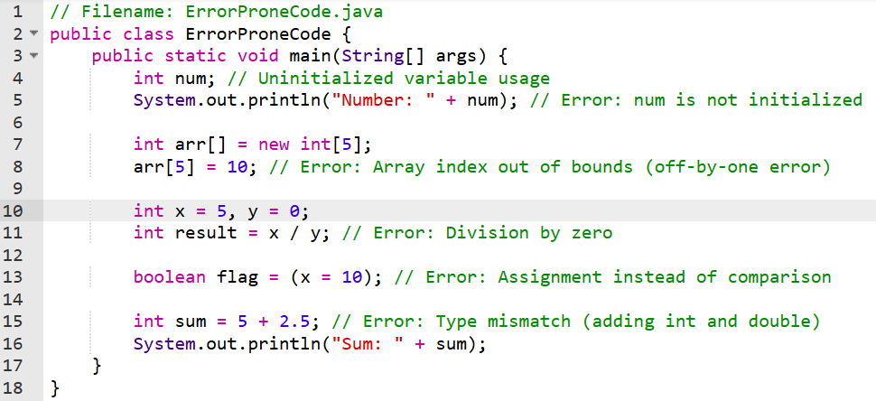

Errors produced by compiler:
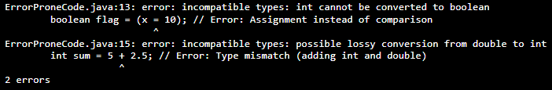
I fixed the issues by following the actions:
- Uninitialized variable is initialized (num = 0)
- Used a valid index arr[4] instead of arr[5]
- Ensured y is not zero before performing division
- Used == instead of = operator
- Used double for mixed-type arithmetic
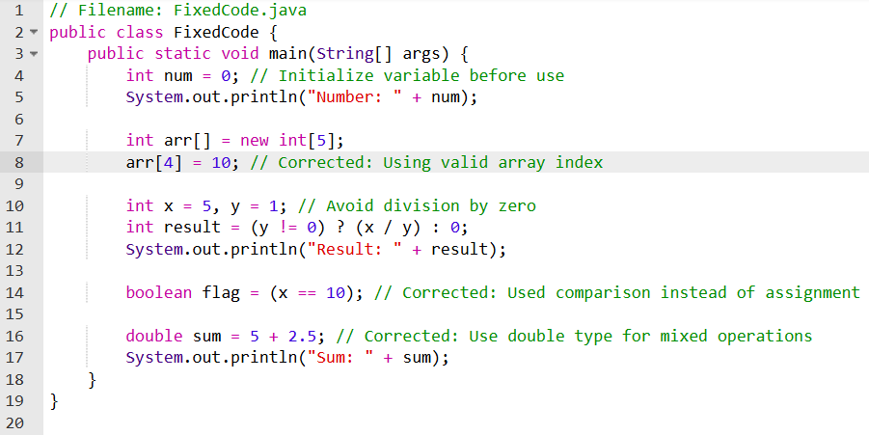
Output:
